GOVT. DEGREE COLLEGE, PORUMAMILLA,KADAPA DISTRICT
INTERNATIONAL YOGADAY CELEBRATIONS.

Name Of The Principal : Dr.S.Naresh

Name and Date of the Event : International Yoga Day ,
21.06.2023
Theme : YOGA FOR VASUDHAIKA KUTUMBAKAM.

Organized by : Dept. of Physical Education

Name of the Coordiantor : Sri.G.Narasimha Reddy,

No. of Students participated : 110 (All Departments)

FESTIVAL OF YOGA AND WELL BEING

Our College Staff, Programme Officer, NSS Volunteers were participated inInternational Yoga Day Celebrations Held On 21.06.2023. In this program our college old student and Yoga Master Sri.B.Bala Rangaiah (HM) garu awareness and importance of Yoga in our busy life, among the students. Honorable Principal Dr.S.Naresh, garu presideded over the function, he delivered the introductory speech on the importance of the YOGA. He emphasized yoga is the only technique which gives relief in our day today busy and stress life Under the guidance of Yoga Master all teaching, non-teaching, NSS volunteers and students practiced IMPORTENT YOGA ASANASlike SURYANAMASKARAS and PRANAYAMAS..

GOVT.DEGREE COLLEGE, PORUMAMILLA, KADAPA DIST
INTERNATIONAL YOGA DAY ON 21st JUNE, 2023

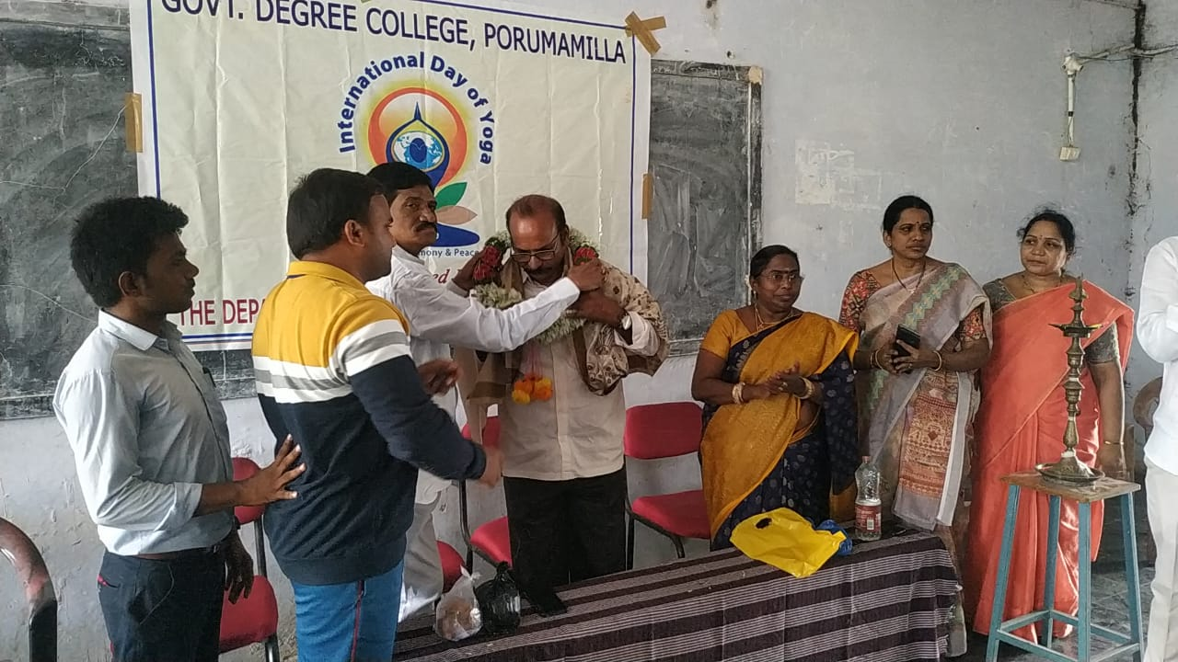 | 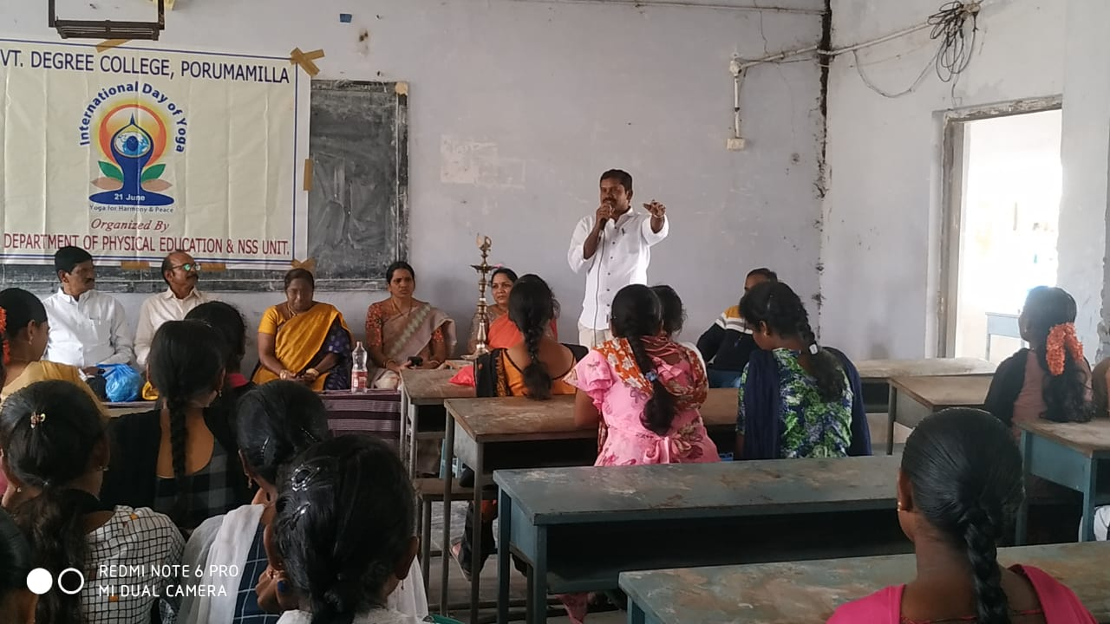
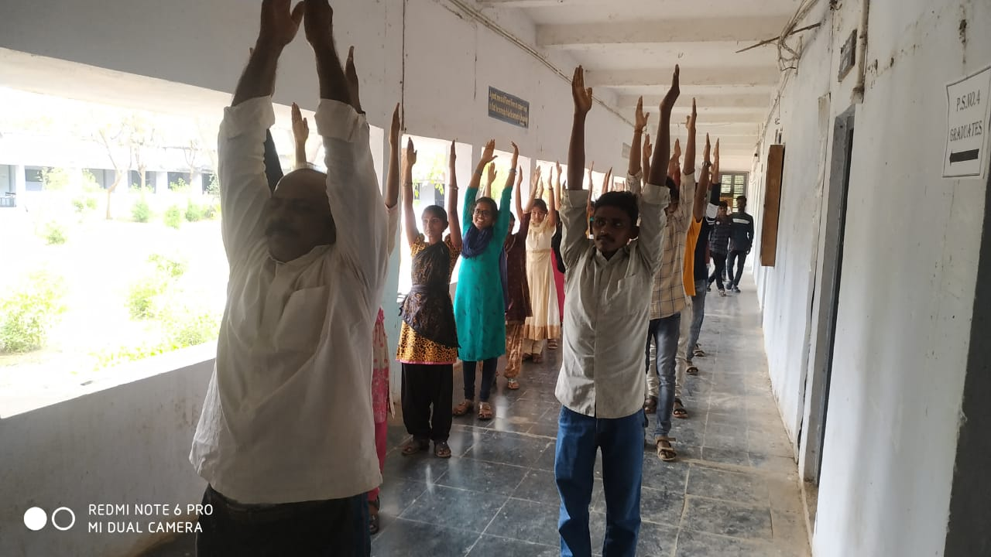 | 